Additional Infectious Diseases & Illnesses Information in Relation to COVID 19
The Little Ark Preschool

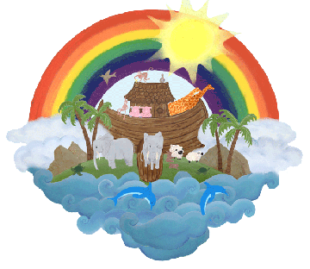

28th May 2020
We have set out the following guidelines as set out by the government (subject to change):
If you have symptoms of coronavirus (COVID 19), however mild, OR you have received a positive coronavirus (COVID 19) test result, the clear medical advice is to immediately self-isolate at home for at least 7 days from when your symptoms started.

After 7 days, or longer, if you still have symptoms other than cough or loss of sense of smell/taste, you must continue to self-isolate until you feel better.

If you live with others and you are the first in the household to have symptoms of coronavirus (COVID 19) then you must stay at home for at least 7 days. All other household members who remain well must stay at home and not leave the house for 14 days. The 14 day period starts from the day when the first person in the household became ill.

If anyone else in the household starts displaying symptoms, they must stay ay home for at least 7 days from when their symptoms appeared, regardless of what day they are on in their original 14 day isolate period.

We are asking that anyone who is displaying coronavirus symptoms, or who lives with someone who does, not to attend the setting. That includes children and staff who work here.
Reduce the spread of infection in your home by washing your hands regularly for 20 seconds using soap and water, or use hand sanitiser, and cover coughs and sneezes.
If you develop new coronavirus (COVID 19) symptoms at any point after ending your first period of isolation (self or household) then you must follow the same guidance on self isolation again.

What can parents and carers do to help?
There are a number of things parents and carers can do to help us make these arrangements effective, in addition to the points listed above concerning arrival and departure and not bringing toys to the setting –
1.If your child or anyone in your household has coronavirus symptoms (new continuous cough, high temperature, loss or change in normal taste or smell) please make sure you do not come to the setting. You need to self-isolate for 7 days and contact NHS 111.
2.If your child develops a suspected coronavirus symptom at the setting then you will need to collect your child immediately, again please contact NHS 111.
3.If your child or anyone in your household has been told to be tested for the coronavirus please keep us informed of the outcome. If the test is negative you are allowed to bring your child back to the setting however if it is positive then you need to self-isolate for 14 days.
Testing
If your chid displays symptoms of coronavirus, we are asking all parents and carers to ensure they organise a test for their child, in the event that they develop coronavirus symptoms and notify us immediately of a positive test. The aim is to enable children to get back to childcare, and parents/carers not to need to self-isolate any longer than is necessary. A positive test will ensure rapid action to protect other children and staff in the setting.
Finally if the setting has a confirmed case of coronavirus we may have to shut but we will obviously keep you updated where possible.

