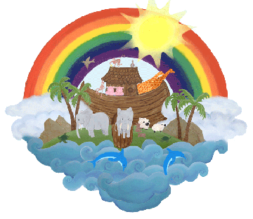
The Little Ark Preschool
Packed Lunch Policy

Our aim is to ensure that children who bring a lunch in from home to eat at the Little Ark Preschool have food which is just as healthy and nutritious as the snacks we serve throughout the day, please try not to put in chocolate bars or fizzy drinks, if they like crisps try to put a few into a little box instead of giving them the whole packet. New research shows that healthy eating in preschool years can influence growth and academic achievement in later life.

Eating healthily is important because:

Good nutrition ensures that children get the right amount of energy (calories) and nutrients as children grow rapidly during this time of their life.
Good nutrition ensures children do not consume too much energy (calories) which may lead to them becoming overweight.
We need to encourage children to eat a wide variety of foods to develop good dietary habits for later childhood and even adulthood.
Healthy eating habits established in childhood help children to be fitter and healthier, develop positive attitudes to food and also help them to learn more quickly and be able to manage their behaviour.

The preschool regards lunchtime as an important part of our day. This represents a social time where children can learn about healthy eating however we do realise that this may not always be practicable and can sometimes this can turn into a battle. Please ensure that they have lots of small amounts of finger food which may tempt them, here are some suggestions:
Fresh fruit
Crunchy vegetables
Meat, hardboiled egg, (unless any children have allergies)
Dairy food such as cheese, milk or yoghurt
Bread, pitta, roll, cracker, fruit bread
Water, soft drinks, fresh fruit juice
Children are not forced to eat or drink, but are encouraged to do so.
Due to allergies please do not use peanut butter or Nutella

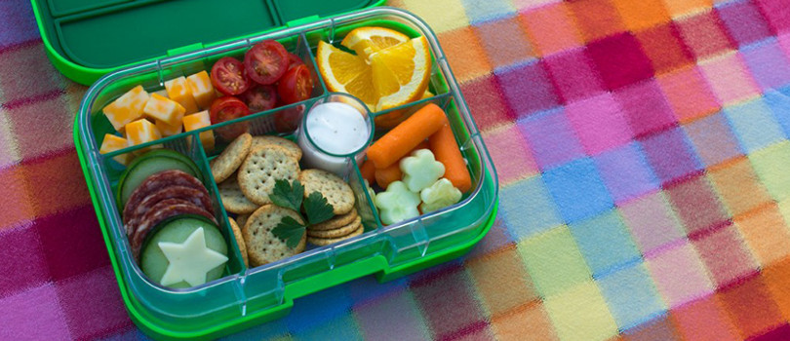

Reviewed June 2020

